How to add a video:
- Make sure the video is saved as an .mp4 and doesn’t have a massive file size. Compress it if needed.
- Save the video into ITube/videos/* and put it into the relevant folder
- Next go to ITube/New/playlists and find the relevant category. For example if I wanted a video to into the ATA Assembly category under High Voltage CA I would open ITube/New/playlists/HVCA/ATA.html
  - If the video you are adding isn’t in a category navigate to relevant folder and add it to the rootVideos.html document
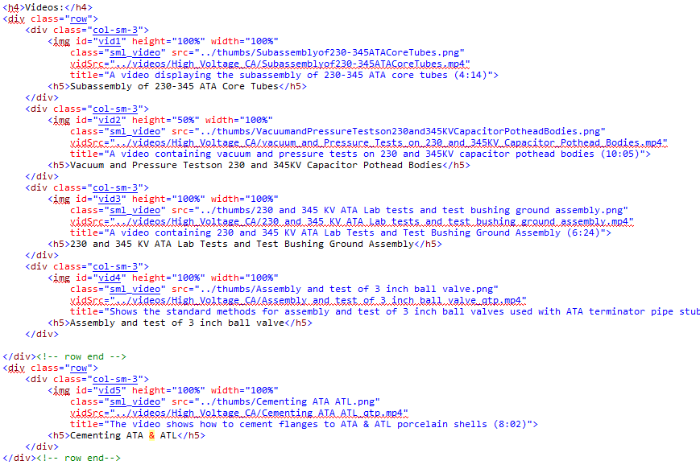
- Once you open up the html file you’ll see something like this:

There will be rows with 4 <img>’s per row. Select an entire div.col-sm-3 and copy and paste it into the next available spot. Make a new row if need be. Make sure there’s only 4 <img>’s per row as it will mess up the rows.
- Now it’s only a matter of changing the img attributes.
  - The id attribute isn’t important.
  - Height and width shouldn’t be touched
  - Class should be sml_video.
  - Src is the thumbnail if you have one. If you don’t you can use “../thumbs/missingThumb.png” which is a question mark.
  - VidSrc is the source of the video you added. Make sure you start the url with “../videos/”
  - Title is the text that appears when the cursor hovers over the picture. Use this as a description of the video and then put the duration in parenthesis.
  - The <h5> tag is the actual title of the video
- That’s it! Save and your video should be on I-Tube.

